North Finchley tour options
Two possible walks from the bus station, prepared for your comments. Neither route is selected or field-verified. The aim is to find the stories that deserve a place before we write the whole tour.
My recommendation: choose A if keeping the outing short matters most. I lean towards B for its variety, if that is worth roughly ten extra minutes. We can also reshape the shortlist around your favourite stories.
 | A Entertainment | B Neighbourhood
Route estimate | 1.4 km · 18.9 min moving | 1.9 km · 26.8 min moving
With stories and pauses | 28–33 minutes | 37–42 minutes
What it offers | Venues and nights out | Art and everyday community
Main compromise | Repeated high street pavement | More walking between stories

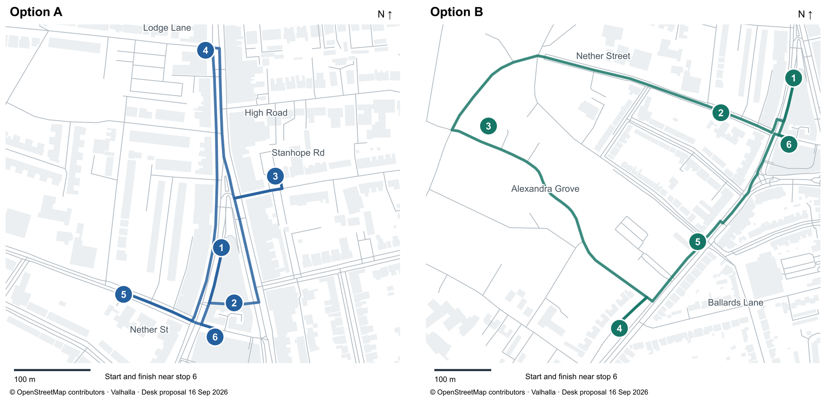
Numbers match the stops on the next two pages. Maps use different scales. Both start and finish near stop 6, by artsdepot and the bus station. Lines and markers are provisional, not walking instructions.
Time basis: saved pedestrian routes at 4.5 km/h, plus 8–9 minutes of stationary stories and 2–5 minutes for looking and crossings. B exceeds the earlier 20–30-minute goal. Access, crossings and useful standing positions still need review. No outing is requested now.

A Places people went for a good time
A compact walk through the places where people met, watched and performed. About 1.4 km and 28–33 minutes. Start by the bus station, walk to Tally Ho, then follow this story order.

1 Tally Ho and the meeting place
Begin with the roads and coaching context, then the cyclist’s postcard from the revised sample. The factual setting gives the quirky anecdote something to attach to. About 1½–2 minutes. The exact coaching-inn footprint remains uncertain.

2 Grand Arcade and the everyday shortcut
A small covered shopping passage with a preservation campaign backed by Dave Davies. What makes an unassuming shortcut worth defending? A story about ordinary use and affection for a place, grounded in its small-shop scale. About 1 minute.

3 Stanhope and a different kind of cinema
An old advertisement offers continuous programmes: turn up and leave when you like. Use it to evoke an evening before the familiar fixed-time feature film. About 1–1½ minutes. The candidate frontage at 14–16 Stanhope Road still needs checking.

4 The Torrington and a night out for 80p
A 1977 bill names John Otway and Wild Willy Barrett, with doors at 8.15 and admission 80p. We can build a strongly supported pub-gig scene around that concrete evening. About 1½ minutes. Ordinary atmosphere is welcome; invented events are not evidence.

5 Trinity and the orchestra behind the door
Finchley Symphony Orchestra rehearses and performs here. Its account combines ambitious repertoire with weekly practice and tea-and-cake breaks: a warm story about people making music together. About 1 minute. We would not rely on hearing a rehearsal or going inside.

6 From the Gaumont to artsdepot
Bring the cinema’s social atmosphere to life, then tell the community story behind the present arts centre. An ending about making a place for audiences again. About 1½–2 minutes. This should feel distinct from Stanhope’s early cinema story.

The tradeoff to judge
The route goes north for the Torrington and returns along the High Road, with short side visits. Tally Ho and the arcade are only about 106 metres apart. The arcade must be open and both stops must earn distinct places to stand. Two cinema stories could deepen the theme or repeat it. I would replace a weak stop before squeezing the arrival rules to fit it.
Sources: Tally Ho evidence · Arcade campaign · Stanhope advert · Torrington bill · Orchestra · artsdepot timeline

B How a neighbourhood makes itself
A broader walk beyond the shops, mixing visible art, houses and community life. About 1.9 km and 37–42 minutes. The shared opening and ending make this an alternative selection, not a wholly separate set of stories.

1 Tally Ho and the junction that gathered people
The same grounded opening as A: roads, coaching and the postcard, before we leave the centre for the neighbourhood. About 1½–2 minutes.

2 Trinity and people making music together
The orchestra story from A, with the emphasis on local people learning and performing together. A small-scale cultural activity before the longer walk west. About 1 minute.

3 The meeting house and rubbish turned into art
Bottle casts and reclaimed roof slate become a wall sculpture inspired by community litter-picking. Containers seem to float among slate waves. This is a strong candidate for a story that changes how you see something right in front of you. About 1½ minutes. The view from an appropriate public position at 58 Alexandra Grove is still unverified.

4 Moss Hall Crescent and the suburban promise
Twelve Victorian villas sit behind a green strip. Their bays, roofs and distance from the road help us picture the kind of life offered when an estate became housing. About 1½ minutes. This is a good place for supported imaginative colour after the factual setting, without inventing particular residents or peering into their homes.

5 The Elephant and a name that survived
The former Moss Hall Tavern links the vanished estate name to a continuing social place. A brief exterior story about that continuity and the rebuilding of the pub. About 45–60 seconds. This is my weakest candidate: it stays only if the view and story justify stopping.

6 From the Gaumont to artsdepot
Return to the bus station area for the shared ending about audiences and the community effort behind the arts centre. About 1½–2 minutes.

The tradeoff to judge
The western circuit offers more residential streets, although Ballards Lane is part of the return. Two middle legs each take about 7½ minutes in the router. That could be welcome breathing room or too much empty walking. There is still a short retrace at the opening and at Moss Hall Crescent. The sculpture point is approximate and sits off the routed street; its final approach needs review.
Sources: Sculpture commission account · Moss Hall Crescent · Local pub history

Alternatives and your feedback

Choices within either proposal
More architecture: St Alban’s could replace Trinity. A carved detail could lead into architect Percy Lamb’s work with Westminster Cathedral’s architect. It is close to B’s western leg, but the revised route and time are not calculated. This is an alternative to the music story, not another compulsory church stop.
More visual discovery: the meeting-house sculpture is the strongest subject to borrow from B. It would add distance to A; it is not a free substitution within the shorter route.
Different emphasis without more walking: tell a particular gig night at the Torrington rather than list famous performers. At artsdepot, emphasise community effort and present use rather than a lament for a demolished cinema.
For a later excursion: the Belarusian wooden church and neighbouring library in Woodside Park look promising. They extend beyond this compact brief and need further access and context research. The church’s commemorative setting also needs careful treatment.

The most useful reactions
Your three strongest stories. Which make you want to walk: postcard, arcade, early cinema, pub gig, orchestra, sculpture, villas or neighbourhood pub? Which would you drop?
Time and variety. Does B earn its roughly ten extra minutes, or should we keep working within A’s smaller footprint?
Repetition and tone. Would two different cinema stories make a good thread? Does the sculpture sound intriguing, or too much like a lesson?
The walking itself. How much repeated pavement or quiet walking would you accept for a stronger story?

What we would do with your comments
First choose a provisional story set. Then write two short passages that test the most important tonal choice, including the supported imagined colour you asked for, and check retained frontages and approaches. We would request a focused visit only for material questions that desk work cannot resolve.
I have collated all 34 earlier Word comments with their anchored text, the conversation corrections, rejected examples and open choices in EDITORIAL-REVIEW-RECORD.md. The repository instructions now direct future content work there. Your response to this version will be added as feedback, separately from any later listening or walking result.
Sources: St Alban’s assessment · Woodside Park discovery source
The companion NORTH-FINCHLEY-TOUR-OPTIONS.md holds the full claim notes and uncertainties; routes/north-finchley-options-v1 holds the actual routing evidence. Maps: © OpenStreetMap contributors, ODbL. Source checks dated 16 September 2026. These proposals do not complete the separate E1 comparison.

